# Module – 6 CloudWatch logs

**Assignment 1 : Create a CloudWatch alarm for an instance**

Below are the steps to create cloud watch alarm for instance:

Step 1: Select EC2 from AWS console and click on ‘Launch Instance’ to launch the instance:

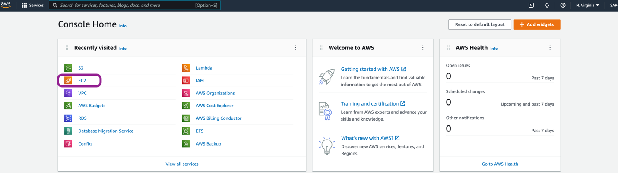

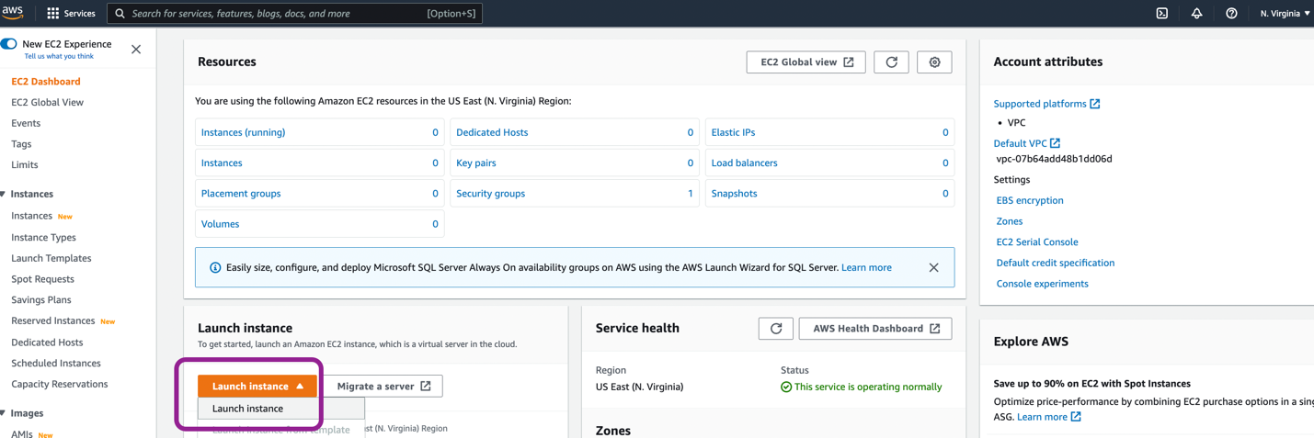

Step 2: Configure the properties and details for instance –

1. Name and Tags
   1. Name : Web Server for Cloudwatch
   2. Select AMI :Amazon Linux 2 AMI (Free tier eligible)
2. Instance type
   1. Instance type – t2.micro (Free tier eligible)
3. Key pair (login)
   1. Key pair name – create new key pair
4. Network settings
   1. VPC – Select existing vpc
   2. Subnet – select subnet
   3. Auto assign public IP – Enable
   4. Firewall(Security group) – Select from existing or create new security group.
   5. Security inbound rule- add rules to allow traffic for inbound request.

Step 3: Click on ‘launch instance’.

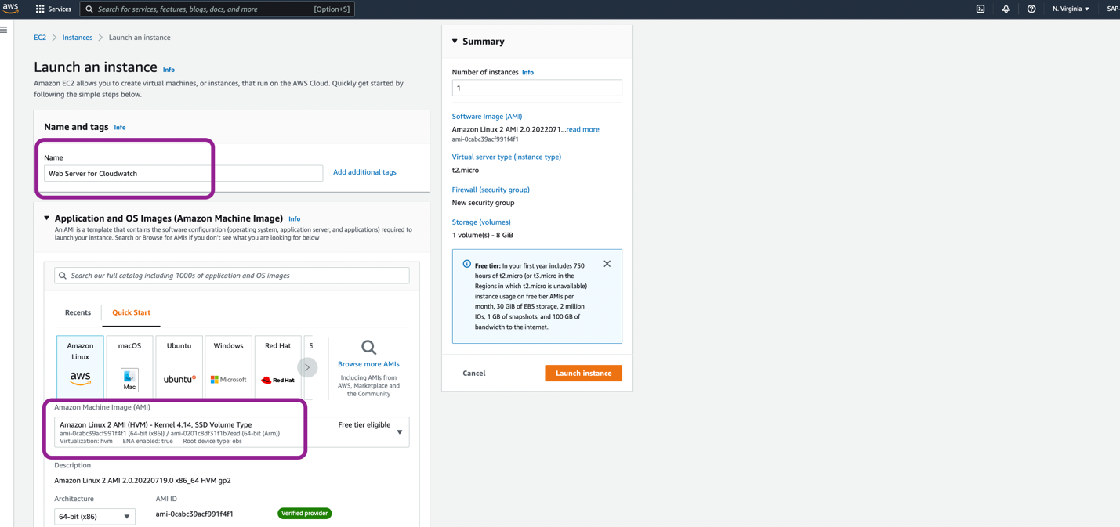

Step 4: Select instance, click on ‘Actions’ then ‘Monitor and troubleshoot’ and click on ‘Manage Cloud watch alarm’.

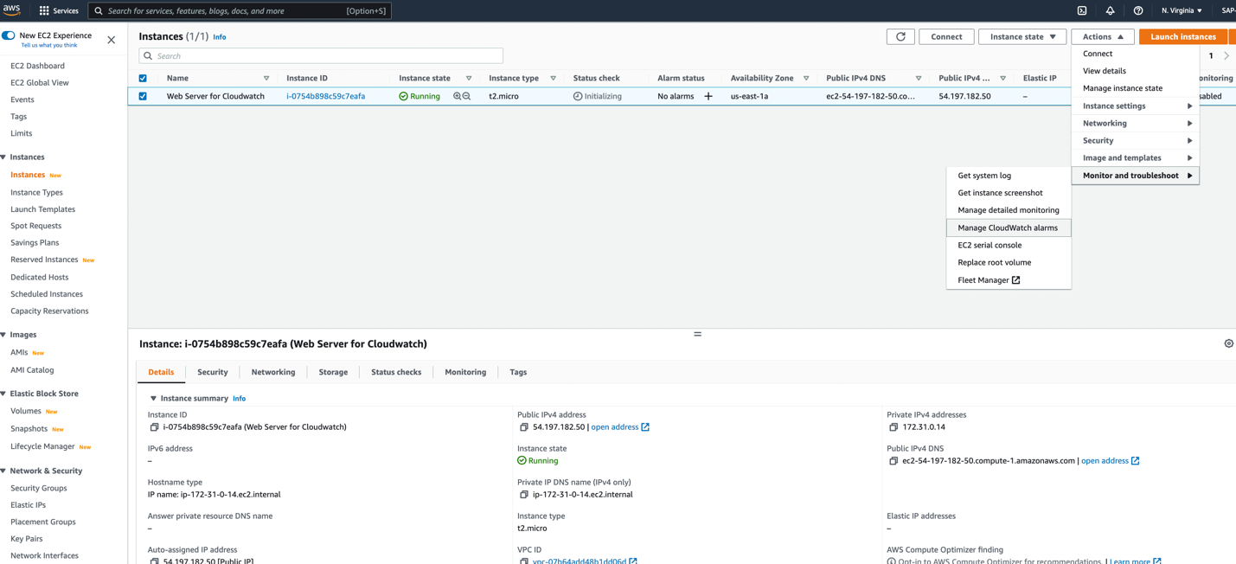

1. Select ‘create an alarm’

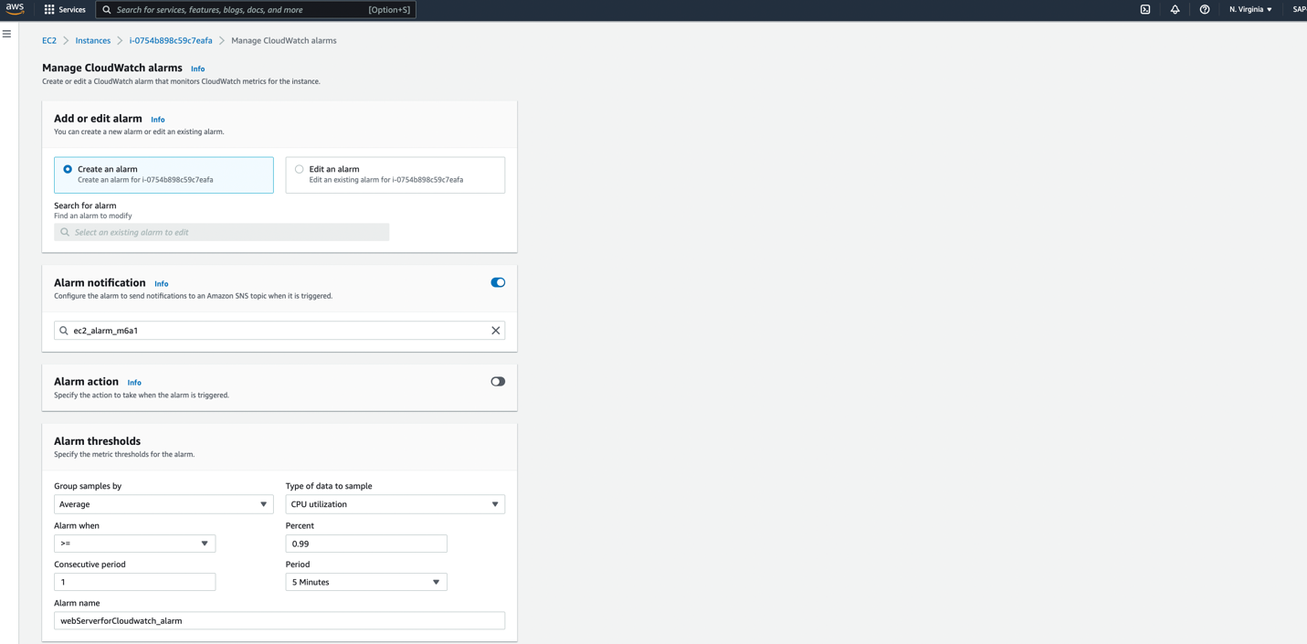

1. Put the alarm notification name
2. If there is any specific action to perform through alarm – configure the ‘alarm action’.
3. Configure the alarm threshold
4. Put the alarm name – webServerforCloudwatch_alarm
5. Click on ‘Create’.

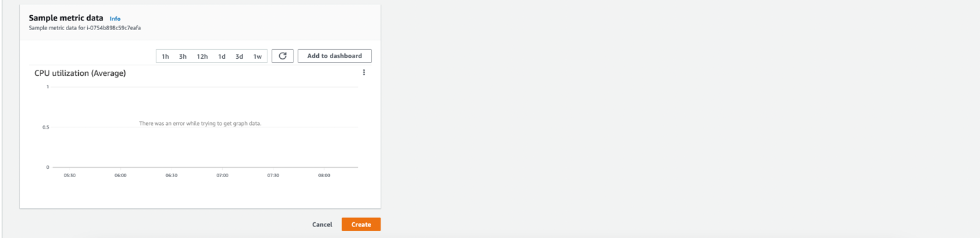

Look for the ‘CloudWatch’ in AWS search box on console. Click on ‘All alarms’. Check the created alarm.

